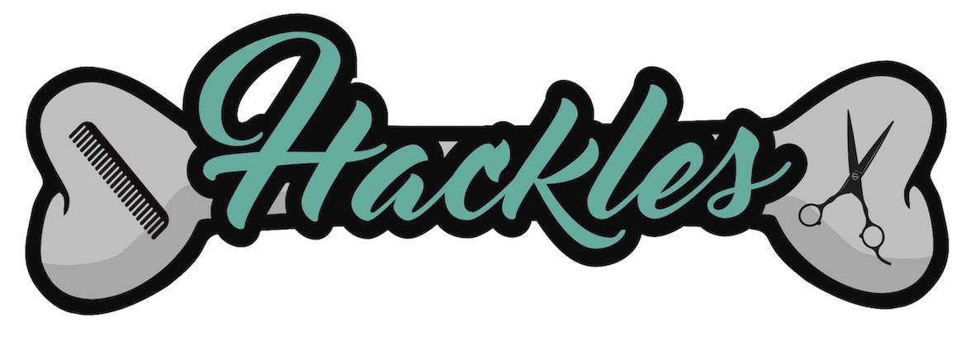
Price List
The following is a list of commonly groomed dogs – if your dog is not listed, please contact me for a quote.
Prices are a guide only and are based on an average dog who is used to being groomed and who's coat is not excessively knotty or matted.
Prices will depend on whether your dog has a full breed style or a pet trim.

Dog Breed | Full Groom | Bath & Tidy
Afghan Hound | £70
Cocker Spaniel | £35+ | £25
Bearded Collie | £50+
Mountain Dog Breeds | £50+
Bichon Frise | £30 - £40 | £25
Border Collie | £30+
Border Terrier | £30 | £20
Cairn Terrier | £30 | £20
Cavachon | £35 | £25
Cavalier King Charles | £30+ | £20
Chihuahua | £25+ | £20
Chow Chow | £50
Cockerpoo | £35 | £25
Cocker Spaniel | £35 | £25
Dachshund Long Haired | £30 | £20
Dachshund Wire Haired | £30 | £20
Setter | £40 | £30
Springer Spaniel | £30+ | £25
Golden Retriever | £35+
German Shepherd | £35+
Huskey | £50+
Irish Terrier | £35 | £25
Jack Russell | £25 - £30 | £20
Labradoodle (large) | £40+ | £30
Labrador | £30+
Lhasa Apso | £30+ | £25
Miniature Schnauzer | £30 - £40 | £20+
Pomeranian | £35+
Poodle Miniature | £30+
Poodle Standard | £45+
Poodle Toy | £30+
Samoyed | £50+
Scottish Terrier | £35 | £20
Shar Pei | £35
Shetland Sheepdog | £40
Shih Tzu | £30+ | £20
Spinone | £40 | £30
Staffordshire Bull Terrier |  | £25
Standard Schnauzer | £35 - £45 | £25
West Highland White Terrier | £30+ | £20
Yorkshire Terrier | £30+ | £20

- Handstripping is charged at £20 per hour
- Puppy Sessions - £25 – if you have a puppy that is going to be
visiting the groomer regularly, it is best to get them used to being
handled and the salon environment as soon as possible. I offer an
introductory session for all puppies up to the age of 6 months.
for more information, please contact me.

